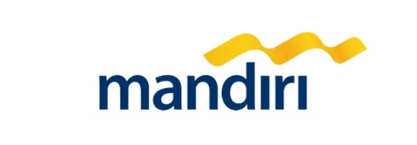

Implementation Partner for FRMS Project – Technical Proposal

**IT Operational Excellence Review**

2016

Copyright and Confidentiality Notice

Copyright © 2016 by UST Global (Singapore) PTE Limited. All rights reserved. This document is protected under the copyright laws of Singapore and other countries as an unpublished work and contains information that shall not be reproduced, published, used in the preparation of derivative works, and/or distributed, in whole or in part, by the recipient for any purpose other than to evaluate this document. Further, all information contained herein is proprietary and confidential to UST Global (Singapore) PTE Limited. and may not be disclosed to any third party; references to UST Global herein are permitted by UST Global Inc. in Aliso Viejo, California, USA. Exceptions to this notice are permitted only with the express, written permission of UST Global (Singapore) PTE Limited.

UST Global is a registered service mark of **UST Global Inc.**

UST Global (Singapore) PTE Limited is a registered entity of **UST** **Global** **Inc.**

Proposal Identification Number: BKMN-0011-01-00

Proposal Expiration Date: Six months from the day of submission

Company Address

31 Cantonment Road,

Singapore 089747

[www.ust-global.com](http://www.ust-global.com)

Fax: (91) 471.2527276

[www.ust-global.com](http://www.ust-global.com)

*PT. Adi Data Informatika*

*Gedung Graha Kencana Lt. 7*

*Jl. Raya Pejuangan No. 88*

*Kebon Jeruk – Jakarta Barat*

*Tel: 021 – 53660016*

*Fax   : 021 – 53675392*

[*www.adidata.co.id*](http://www.adidata.co.id)

*Contact : Ridwan Yulianto*

*Email : ridwan@adidata.co.id*

*Mobile : 0811 150 125/ 0818 111 699*

Contents

1 Executive Summary 4

2 Our Understanding 7

2.1 Scope of Work 7

2.2 Out of scope 9

3 Project Roles and Responsibilities 11

3.1 Roles and No. of Positions 11

3.2 Roles and Responsibilities 11

3.3 UST Team sample profiles 16

4 Assumptions 17

5 Governance Model 18

5.1 Reporting and Communication 18

5.2 Escalation Model 19

5.3 Change Management 19

5.3.1 Change Control Board Process 19

5.3.2 UST Change Management 20

5.4 Risks 21

6 UST’s Partnership with FICO 22

7 Knowledge transfer from UST to Bank Mandiri 23

8 Appendix – Case Studies 24

# Executive Summary

UST Global is delighted to present its response to the Request for Proposal (RFP) from Bank of Mandiri for Fraud Risk Management System (FRMS) implementation. We understand Bank of Mandiri wants to identify a partner with implementation support expertise to implement the Falcon FRMS solution on a wide range of Bank Mandiri’s devices, e-channels, online financial platforms, ATMs, branches and call center activities.

**Solution Highlights**

UST will be providing FICO FRMS implementation support and transfer of knowledge of its project management and system integration best practices to Bank Mandiri. Specifically, the UST implementation support team will augment the current implementation team with the defined roles. UST will provide the needed support to integrate Falcon FICO Fraud and Risk Management system with the relevant bank surrounding systems and platforms to the expectation of Bank Mandiri.

The core team from UST will include –

* 1 Senior Project Manager
* 1 Business Stream Lead and 2 Business Stream Analysts
* 1 Integration Lead and 1 Integration Analyst
* 1 Technical Writer, versed in the Indonesian language

**Why UST**

We believe that our culture and values make us a good fit for, and thus will ensure, a very successful relationship. UST Global is uniquely qualified to provide exceptional value and high quality services to Bank Mandiri considering our expertise, service capabilities and long term commitment to the relationship. We have more than a decade of expertise in providing similar services to leading global financial institutions and helping them achieve compelling results and Return on Investments. Some of these unique values that differentiate us are as follows:

* **UST’s partnership with FICO** – UST has partnered with FICO to offer world class analytics and payment integrity solutions to our customers. We have joined hands with *FICO® Payment Integrity Platform* that uses deep predictive analytic modeling to reveal payment practices and policies leading to leakage and lost money for our customers in the healthcare domain. More details on our relationship has been explained in *section 6 – UST’s partnership with FICO*
* **BFSI Domain Expertise** – UST has professionals who have vast domain expertise in the banking industry. We have experience in developing core services and solutions for banking, integrating as well as implementing innovative solutions to the ecosystem by introducing new channels such as mobile, social media, etc. We provide these services for some of the largest banks and leading mortgage lenders in US.
* **Fraud Detection Experience –** UST has a strong experience in implementing fraud detection services at various segments and levels. UST coordinates strategies embracing multiple areas to limit exposure and improve effectiveness that are now mandated by the U.S. Federal Financial Institutions Examinations Council and other regulatory agencies worldwide
* **Project / Program Management** - UST Project management expertise consists of more than 500 project/ program managers with an average experience 20 years. Our project/program managers gained knowledge from the complex IT program execution along with relevant certifications from accredited bodies such as the PMI, Scrum Alliance, ITIL etc.

UST Global project management methodology is based on the project management framework developed by the Project Management Institute (PMI), and we follow the PMI-recommended guidelines and project management processes. UST Global brings to the table its Project Management expertise developed and perfected by its numerous engagements with its Global 1000 clients. The approach envisioned for the client would be tailored to effectively manage the development projects using our onsite-offshore model. Because we want it to be easy for you to do business with us, UST Global is also willing to adapt to the client’s approach to Project Management.

* **Technology Depth** – Expertise in fraud, info security, speech/IVR, localization, internationalization etc. hosted at customer location or on a cloud service model supporting high volume transactions.
* **UST relationship with Bank Mandiri** – UST’s relationship with Bank Mandiri started in the Q4 of 2015 and in this short period of time our relationship has grown tremendously. We have successfully executed a number of projects that have been of great value addition to Bank Mandiri. Some of our projects with Bank Mandiri includes -
* MDM Testing
* EDM Consulting services
* MCM testing assessment
* IT SDLC & IT Ops Assessment, including IT Infrastructure and Testing Assessments
* SCM Testing (ongoing)
* **Client Centric Engagement Model:** UST Global follows a client centric engagement model wherein we will endeavor to develop a deep long term partnership with Bank of Mandiri by having focused senior executive oversight and management.

Conclusion

UST Global believes that our most important differentiators are our depth of experience in providing implementation and Project management support for similar engagements, our dedication, and commitment to delighting our customers. This involves what we refer to as “Commitment beyond Contract”, and also our willingness to invest in our clients up-front and continually throughout the relationship. We are demonstrating some of these factors in this proposal, and would ensure that Bank of Mandiri experiences these in our relationship. Finally, UST Global is committed to support the on-going business needs of Bank of Mandiri and will devote the full attention of our management team to ensure Bank of Mandiri’ s satisfaction throughout this engagement

# Our Understanding

We understand Bank Mandiri is looking for a partner with expertise to support in the implementation of FICO Fraud Risk Management System (FRMS). The solution will include multiple integrations with other systems and be implemented on a wide range of Bank Mandiri’s devices, e-channels, online financial platforms, ATMs, branches and call center activities. The Bank is planning to have a strategic engagement with a partner to ensure that the delivery of the project will meet timeline, quality and as per agreed scope that will help business in gaining momentum while balancing the risk. The selected Implementation Partner will be responsible for providing implementation support as per the roles specified in the RFP, project management office support and knowledge transfer to the Bank team during the project implementation phase.

## Scope of Work

UST proposes the following technical solution to address section 3 in the RFP -

UST with its extensive system integration experience proposes a staff-augmentation engagement support to Bank Mandiri team in the implementation of the FRMS solution, consisting of senior project manager, business stream lead, business stream analyst, integration lead, integration analyst and technical writer as requested by Bank Mandiri to support execution and management of the proposed FRMS implementation. The roles and their respective responsibilities and deliverables are detailed out in section 3.2 – Roles and Responsibilities.

UST will also provide our execution leadership capabilities for governing the overall UST team engagement and performance section 5 – Governance Model. UST team will engage in supporting all assigned work in alignment with Mandiri program management direction. Any changes impacting timelines, cost and quality of the integration program will be managed through the change management process Section 5.3 – Change Management.

The UST implementation support team will focus on the assigned program operations by working with the Bank Mandiri core program team from both AppDev and business users. UST business stream team will support the Bank Mandiri business core team in further eliciting business needs and building quality requirements documents applicable for identified features within the available bandwidth. The integration team will support the review of solution designs and technical implementation details working with the bank Mandiri technical core team within the available bandwidth.

The UST Senior Project Manager will work on the assigned stream tasks under the direction of Bank Mandiri Program management which may include:

* Support in the creation of Plan for project delivery and execution including migration strategy
* Review the risks / issues identified and mitigations during project execution, ensure respective owners track them to closure
* Check if the estimates are reviewed by relevant Bank Mandiri stakeholders
* Review type of methodology
* Review project schedule /WBS prepared by various PMs
* Review major skill requirements of the project, check if the identified resources are meeting the project needs and the training needs identified are suitable.
* Ensure projects are initiated as per the standards & Project Initiation meetings are conducted by respective PMS
* Track the obtained commitment for the project milestones / deliverables / timelines from all relevant stakeholders
* Track Project Planning
* Monitor project efforts
* Track and report project performance by providing real-time and comprehensive view of the project to management
* Interface effectively with Senior Bank Management (Board/Director), Implementation team and user groups
* Actively participate in team meetings
* Ensure familiarity and compliance with customer’s policies and processes
* Escalate to relevant stake holders & Senior management on the high risks as appropriate
* Monitor resource requirements required for the project and escalate / report to Senior management / directors in case the resources are not available, in accordance with criteria
* Review of plan and strategy for implementation
* Identify, review and mitigation of the risks during the project implementation
* Review and Supporting of the issue resolution
* Ensuring the availability of project management support resources in accordance with criteria and provide replacement resources that has the same qualifications/skills in case the performance of assigned resources are not as expected or if resources cannot continue the work
* Providing regular report and communication to related stake holders
* Follow agreed escalation mechanism for outliers

The Business Stream support will work on the assigned stream tasks under the direction of Bank Mandiri Program management which may include :-

* The cross-functions requirements gathering and elicitation
* Develop, update and manage the Requirement Traceability Matrix started from initial requirement document such as: BRD and SOW created by Mandiri core team.
* Propose best utilization of application functionalities
* Review and support Mandiri implementation core team: to develop and review the functional specification and recommendation documents
* Propose the right reporting and reconciliation solution (if any)

UST Technical Team consisting of experienced professionals with system integration experience of similar nature, size and complexity and will work on the assigned stream tasks under the direction of Bank Mandiri Program management which may include:

* Support the formulation of solution design and implementation strategy as per common practice
* Support core Mandiri team in review and development of the functional, technical specification and architecture recommendation documents
* Propose and support the design of appropriate reporting and reconciliation solution (if any)
* Support the integration of FRMS with all surrounding systems
* Support the software installation for all environment (Sanity Testing, VIT, SIT, UAT, Security Test, Performance Test, Load Test, and Stress Test, Production and DRC)
* Support the synchronization of DC and DRC environments
* Support the review of development and customization FRMS and the related integration as per agreed in functional and technical documents
* Support the setup and installation of core and supporting systems for go live both in DC and DRC environments
* Support in the migration system
* Support the Production Trial Run (PTR) to ensure the solution works well
* Support the production cut over
* Support the switch over test run in DRC (if any)
* Support for post implementation support after control release and 6 months after go-live

UST Tech Writer will work on the assigned tasks under the direction of Bank Mandiri Program management which may include:

* Support and monitor the fulfillment of training materials development by FRMS provider (technical and functional)
* Support the development of guiding principles for the system, at minimum: user guide, installation guide, data dictionary and technical software configuration
* Documentation of the training plan and delivery for both IT and End Users (Users & Administrators)

## Out of scope

* UST does not own the creation of Implementation solution design, development, testing and documentation to integrate Falcon FICO FRMS system
* UST does not own the development of integrating the FRMS
* UST does not own the development of BRD, SOW, TAD, FSD, TSD, VIT, SIT & various other testing, as well as the Release/Post-Production Support Plan.

The responsibilities of testing roles are not included in the current staff-augmentation support:

* Evolve the test strategy as well as test data management strategy
* Support the evolution of test and test data management plans
* Identify and propose the testing methodologies and tools
* Support the testing cycle timelines across Sanity Testing, VIT, SIT, UAT, Security Test, Performance Test, Load Test, and Stress Tests.
* Support the development of testing management plan as preparation of testing and the development of test scripts / cases
* Support and coordinate the preparation for Sanity Test, VIT, SIT, UAT, Performance Test, Stress Test, Security Test and DRC Testing (including the environment)
* Support the monitoring of execution of Sanity Test, VIT SIT, UAT, Performance Test, Stress Test, Security Test and DRC Testing with all related parties both from Bank Mandiri Teams and from FRMS Vendor’s team
* Support the monitoring of testing execution and defect fixing within the testing phases of Bank Mandiri
* Support and coordinate the development any documentation related to testing plan, test case, test script, deployment plan (detail implementation, data migration, run down, roll back plan, and risk mitigation), and operations management

The responsibilities of data roles are not included in the current staff-augmentation support:

* Propose best practices in establishing the appropriate data flow and data migration strategy
* Support and guide in identifying the data impacts across systems
* Review and support data base modifications and documentations
* Review and support the data mapping deliverables where needed
* Support the conversion and migration of data from the current related system (if any)

Please note that anything not mentioned in the detailed scope of work in section 2.1 will also be considered as out of scope.

# Project Roles and Responsibilities

## Roles and No. of Positions

|  |  |  |
| --- | --- | --- |
| **#.** | **Roles** | **No. of positions** |
| 1 | Senior Project Manager | 1 |
| 2 | Business stream Lead | 1 |
| 3 | Business Stream Analysts | 2 |
| 4 | Integration Lead | 1 |
| 5 | Integration Analyst | 1 |
| 6 | Technical Writer | 1 |

## Roles and Responsibilities

|  |  |  |
| --- | --- | --- |
| **#.** | **Profile** | **Roles and Responsibilities** |
| 1 | Senior Project Manager | Senior Project Manager will work on the assigned stream tasks under the direction of Bank Mandiri Program management which may include:   * Synchronize interrelations among project activities to meet program target * Manage, support, and integrate program and project level activities * Manage communication with all stakeholders including Steering Committee * Manage the project team to execute the plan * Manage the Risks during project execution * Review project realization plan and strategy * Provide project status reports * Update status, escalate issue, and resolve issue * Validate implementation strategy * Assist in roll out plan and roadmap * Facilitate communication between related vendors * Ensure FRMS Application Vendor and related Vendors perform proper development, unit testing, deployment and configuration of the software |
| 2 | Business Stream Lead | The Business Stream Lead  will work on the assigned stream support tasks under the direction of Bank Mandiri Program management which may include:   * Lead role of a subject matter expert in requirement elicitation * Coordinate all users across all of Project phases * Propose deployment strategy based on requirement from Business * Enhance opportunities by identifying current rules for each channels to be developed * Analyze and decompose complex requirements related to FRMS * Perform gap analysis and recommend solutions * Review and validate Functional Specification Document (FSD) and Requirement Traceability Matrix (RTM) that are created by the vendors. * Review document requirements, functional specifications and wireframes/flowcharts * Analyze and confirm the test criteria and test cases as well as supporting the execution of the testing by users * Review UAT (User Acceptance Test) results * Oversee the development of the product as per the specifications * Facilitate change and configuration management * Validate the functionality of the end product according to the requirement specifications * Develop, update and manage the Requirement Traceability Matrix started from initial requirement document such as: BRD and SOW created by Mandiri core team. * Propose best utilization of application functionalities * Review and support Mandiri implementation core team: to develop and review the functional specification and recommendation documents * Propose the right reporting and reconciliation solution |
| 3 | Business Stream Analysts | The Business Stream Analyst will work on the assigned stream support tasks under the direction of Bank Mandiri Program management which may include:   * Fulfill the role of a subject matter expert in requirement elicitation * Analyze and decompose complex requirements related to FRMS * Perform gap analysis and recommend solutions * Review and validate Functional Specification Document (FSD) and Requirement Traceability Matrix (RTM) that are created by the vendors. * Own the RTM * Review document requirements, functional specifications and wireframes/flowcharts * Analyze and confirm the test criteria and test cases as well as supporting the execution of the testing by users * Review UAT (User Acceptance Test) results * Validate the functionality of the end product according to the requirement specifications |
| 4 | Integration Lead | UST Integration Lead with system integration experience of similar nature, size and complexity will work on the assigned stream tasks under the direction of Bank Mandiri Program management which may include:   * Assess and analyze technical requirement related to integration FRMS with other system * Coordinate communication between all technical team across all impacted streams * Collect, analyze and confirm from the relevant parties regarding integration requirements * Review documentation of technical requirements in the form of Technical Specification Document (TSD), Technical Architecture Document (TAD) and Requirement Traceability Matrix (RTM). * Build comprehensive testing strategy to accomplish SIT and UAT milestones according to Project Plan * Analyze and confirm the test criteria and test cases as well as supporting the execution of the testing (including testing interface) * Review VIT (Vendor Integration Test) and SIT (System Integration Test) results * Support project manager to ensure the quality of the delivery of project milestones and deliverables as per Bank Mandiri’s SDLC especially for those related to technical aspects of the solutions * Ensure integration of FRMS with all surrounding systems * Recommend and ensure the implementation align with the end state architecture * Monitor gap analysis from business capabilities, application, and technology |
| 5 | Integration Analyst | UST Integration Analyst with system integration experience of similar nature, size and complexity will work on the assigned stream tasks under the direction of Bank Mandiri Program management which may include:   * Assess and analyze technical requirement related to integration FRMS with other systems * Collect, analyze and confirm from the relevant parties regarding integration requirements * Review documentation of technical requirements in the form of Technical Specification Document (TSD), Technical Architecture Document (TAD) and Requirement Traceability Matrix (RTM). * Analyze and confirm the test criteria and test cases as well as supporting the execution of the testing (including testing interface) * Review VIT (Vendor Integration Test) and SIT (System Integration Test) results * Ensure integration of FRMS with all surrounding systems * Support synchronize DC and DRC environments * Setup testing tools which require to conduct testing * Provide guiding principles for the system |
| 6 | Technical Writer | UST Technical Writer will work on the assigned tasks under the direction of Bank Mandiri Program management which may include:   * Work with internal teams to obtain an in-depth understanding of the product and the documentation requirements * Prepare user manuals, user guide and operational standard document * Analyze existing and potential content, focusing on reuse and single-sourcing opportunities * Create and maintain the information library * Produce high-quality documentation that meets applicable standards and is appropriate for its intended audience * Write easy-to-understand user interface text, online help and developer guides * Create tutorials to help end-users use a variety of applications * Responsible for storage, cataloging and retrieval of documents * Maintain the integrity of working documents and update documentation when revised * Maintain systems for document storage and retrieval, and help employees on efficient system usage * Responsible for document security, for assigning access, and for removing and destroying obsolete documents |

## UST Team sample profiles

|  |  |  |
| --- | --- | --- |
| **#.** | **Role** | **Profile** |
| 1 | Senior Project Manager |  |
| 2 | Business Stream Lead |  |
| 3 | Business Stream Analyst |  |
| 4 | Business Stream Analyst |  |
| 5 | Integration Lead |  |
| 6 | Integration Analyst |  |
| 7 | Technical Writer |  |

# Assumptions

* Senior PM shall be executing his responsibilities based on the available documented project management process available in Bank Mandiri
* Senior PM can suggest changes to the existing project management process, any changes shall be approved by the change control board or equivalent.
* Any addition in the responsibilities expected should be considered as addendum to this SOW and should be signed off by all stakeholders.
* Senior PM shall facilitate estimate reviews, risk mitigations, however it shall only be implemented after approval from relevant Bank Mandiri authorities.
* It shall be the responsibility of Bank Mandiri to provide authority to review & audit any relevant vendor processes followed in FRMS project
* It is assumed that vendors agree to allow Senior PM access to the project artifacts, assets, data and relevant environment
* Solution and technical implementation partner will be pre-selected by Bank Mandiri
* Proposed FRMS solution assessment and suitability will be established by Bank Mandiri.
* Appropriate agreements are in place for assigning right skills and resources from vendors for each stream including SMEs and leads
* Bank provides required functional and senior management staff as per plan and strategy on time
* Bank provides the required software, tools and packages for effective support

# Governance Model

The overall ownership of the project would be with the Bank Mandiri assigned program manager/PoC with support from Senior PM. This team would be responsible for management of day-to-day assessment activities, aligned with the plan based on bandwidth and program priorities.

The Bank Mandiri Program Manager/PoC is responsible for ensuring that the needed support is provided to the Senior PM as mentioned below:-

* Ensuring any issues are dealt with promptly and escalated when necessary
* Actively participating throughout the project period

## Reporting and Communication

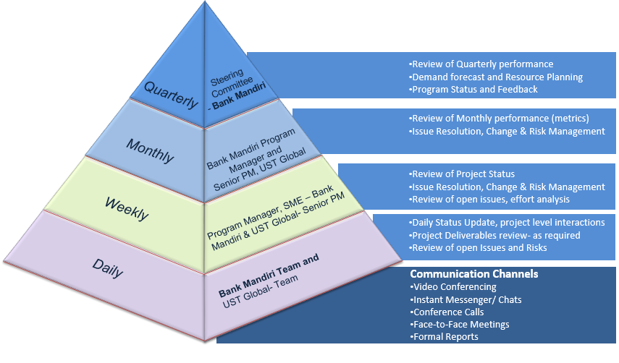

## Escalation Model

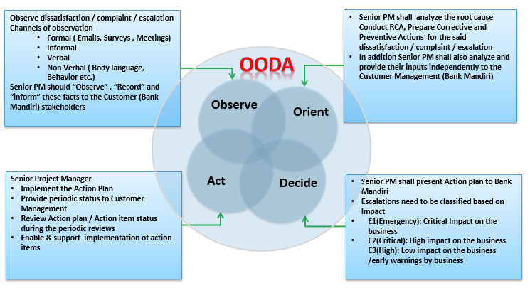

## Change Management

### Change Control Board Process

UST proposes setting up of a Change Control board (CCB) for the governance of the FRMS implementation program change management. UST foresee great deal of business and integration changes in such long running programs of more than 6 months. A well-oiled change management process governed by the unique Change Control board work flow detailed as given; guarantees the smooth and timely adoption of the business and environment changes in the long run.

CCB constitutes of senior management from Bank Mandiri, UST Senior Project Manager, Respective Vendor managers. Changes could be initiated by any of the implementation stakeholders. These change proposals are submitted to CCB which is expected to meet and decide on a regular basis preferably once in 2 weeks.

While final approval authority lies with Bank Mandiri management, the change control board is responsible and accountable for the review, approval and recording of all changes in the program. UST Senior PM will be involved in this change management process based on his bandwidth and Bank Mandiri priorities.

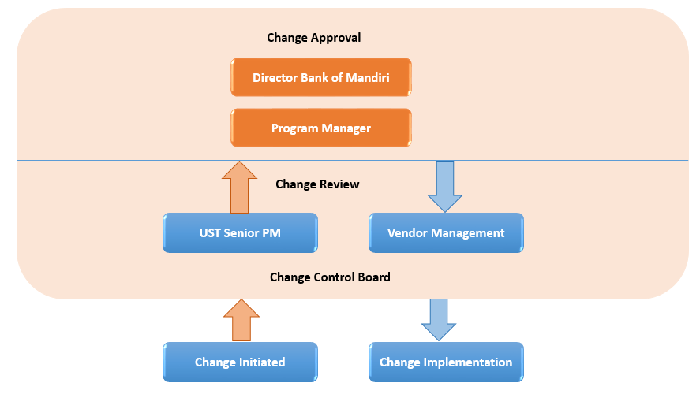

### UST Change Management

This section describes the change management process that would be followed between UST and Bank Mandiri pertaining to this RFP and subsequent SOW. During the project, either party may request in writing additions, deletions, or modifications (“change”) to the services described in the agreed upon statement of work. We shall have no obligation to commence work in connection with any change until the estimated fee and schedule impact of the change is agreed upon in a written Change Request Form and Contractual Amendment signed by duly authorized customer officials.

Upon a request for a change, we shall submit the change on our standard change Request Form describing the change, including the estimated impact of the change on the project schedule, fees and expenses to the CCB detailed in section 5.5.1. Both parties agree to follow this process and to use the Change Request Form. The Change Management Process that we will employ is defined below:

|  |  |
| --- | --- |
| * Identify and document * Assess impact and prioritize * Estimate required effort * Approve / disapprove | * Assign responsibility * Monitor and report progress * Communicate change resolution |

Within three consecutive business days of receipt of the proposed Change Request Form, Bank Mandiri shall either indicate acceptance of the proposed change by signing the Change Request Form or advise us not to perform the change. If Bank Mandiri advises us not to perform the change, then we shall proceed only with the original scope of assessment. In the absence of Bank Mandiri acceptance or rejection, we will not perform the proposed change

## Risks

UST follows standard risk management process and procedures to mitigate and plan for potential risks during the execution of the project/program. At each phase of the project UST will identify potential execution risks, mitigate and manage the risk and also log it for tracking to closure. Following are some of the potential risks foreseen in the UST scope of this RFP during the execution (not an exhaustive list).

* Unavailability of the implementation team to provide timely support to the Project Management team may impact schedule and cost
* Unavailability of timely guidance and support from SMEs and management of Bank Mandiri may impact the schedule and cost
* Unavailability of processes and project management tools from Bank Mandiri
* Testing and data roles responsibilities are currently not in the UST scope which may have an impact to the support of the respective roles expected in the program

# UST’s Partnership with FICO

UST has partnered with FICO to offer analytics and payment integrity solutions based on FICO Payment Integrity Platform for healthcare. In this partnership, UST offers to its customers a FICO-based Business Process as a Service (BPaaS) called Zero Platform Payment Integrity Solution.

## Zero Platform Payment Integrity Solution –

UST Global provides a comprehensive Business Process as a Service solution called **Zero Platform Payment Integrity Solution** to detect and prevent healthcare fraud, waste and abuse leveraging Cognitive Analytics and Clinical resources. UST Zero Platform Payment Integrity Solution empowers healthcare payers to quickly stop fraud, waste and abuse before or after payment, ending the vicious cycle of “pay and chase”.

UST’s Zero Platform Payment Integrity solution in fact goes beyond pay-and-chase methodologies to monitor claims in near real-time. We take the initiative further by applying technologies that specifically predict and identify potential threats. Our Payment Integrity Platform is an enterprise solution that addresses payment error issues, including fraud, waste and abuse, with out-of-the box adaptive predictive analytics.

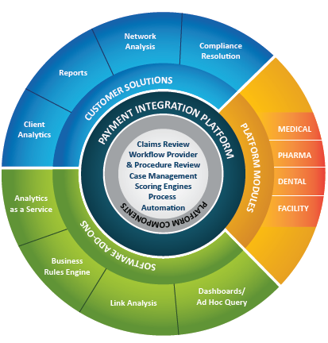

**UST Zero platform payment integrity solution provides** -

* Adaptive Predictive Analysis
* Superior Fraud Detection
* Ability to score one Billion claim lines
* Business Process as a Service

**Key Benefits** -

* One stop shop for Fraud, Waste & Abuse solutions; No separate cost for Platform, Business Process services, Infrastructure, etc.
* End to End ownership and outcome based pricing
* Leveraging Design for happiness to create a customized solution based on client needs
* UST’s channels of innovation & COE to improve service delivery along with cost reduction and ROI
* Domain expertise & thought leadership aligned to achieve business goals
* Access to Digital edge technologies to digitally transform the business with minimal set-up time and effort
* Experienced Clinical resources for higher recovery & positive provider experience

# Knowledge transfer from UST to Bank Mandiri

UST will provide active mentoring programs where the resources at Bank Mandiri will be mentored by Senior Project Managers at UST. The Senior PM’s will guide the resources at each streams to achieve their job level and professional goals. This “mentor- mentee” program is assessed for each resources on a periodic basis.

Following will be the steps undertaken during the Knowledge Transfer process between Bank Mandiri and UST -

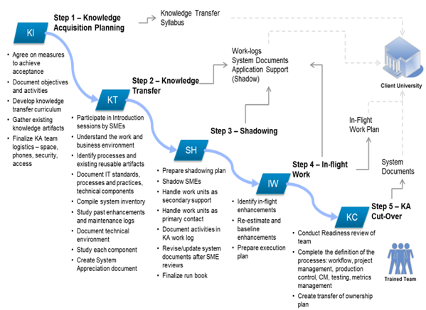

At the end of each phase of the project, UST will be handing over all documentations that include process definitions, project planning, project scheduling and trackers.

# Appendix – Case Studies

| Case Study 1: PMO for Process Definition and Implementation support for one of the leading banks in Malaysia | |
| --- | --- |
| **Business Requirement:**   * The Bank had no Quality Department Office (QDO) and wanted to set up a robust QDO which had defined processes, roles and responsibilities for the Quality Manager, Change manager and Risk manager * In addition to this the bank also wanted to clearly define and execute the roles and responsibilities of the Project Director at the QDO | |
| **UST Global Solution:**   * UST was chosen by the bank to be a strategic partner to provide PMO support in Process definition and Implementation support * 4 resources from UST was identified to work onsite (Malaysia) along with the team members at the Bank * Processes, templates, guidelines and communication processes were defined for the QA Managers, Change managers and Risk managers * UST team provided training programs for Quality Assurance managers, Change managers, Risk Managers and Project Directors * Training and education was provided to Project Directors on how to run project meetings, Project reviews, prepare documentations * Quality Managers were trained to provide all Quality Assurance assessment activities. project reviews, project status meetings with the Governor | **Benefits to Client:**   * UST was successful in setting up a well-trained team and implementing the end to end processes at the Bank * All processes, templates and guidelines for the Quality Manager, Change manager and Risk manager were streamlined. This strengthened the QDO team in parallel |

| Case Study 2: Project Lifecycle development (PMO) for our client which is a Global insurance company who provides a portfolio of life and pensions, general insurance, health insurance, and asset management products and services in the United Kingdom | |
| --- | --- |
| **Business Requirement** **:**   * Current level of interactions between various functions during project lifecycle are not well defined as it lead to lack of clarity in ownership and accountability * Lack of certain process, templates and obsolete ones within the SharePoint * Confusing and inconsistent interaction points. Unclear information flow and existing templates * Lack of ownership and accountability for each functional area within business support units and Information Technology departments * Project Lifecycle Information is with multiple departments and not readily available | |
| **UST Global Solution:**   * Review current Project Lifecycle process : * Review current Lifecycle process maps and improvement actions * Analyze existing artifacts and templates and identify information gaps * Establish roles and responsibilities for all steps in the Life Cycle * Streamline the BC-IT developed Lifecycle process: * Modify process based on the improvement actions * Enhance templates and get a new set of consistent templates * Develop interaction map, roles and responsibilities * Roll out and assist throughout implementation * Create SharePoint repository for artifacts with appropriate classification * Perform road shows and presentations to create awareness and education of new process. | **Benefits to Client:**   * Streamlined communication between business units and IT stakeholders * Reduced project delivery cycle time by 20% * Improved project delivery quality by 30% * Enhanced consistent and clear communication between the involved stakeholder during project delivery |

| Case Study 3: BA Mentorship Program for our client which is a U.S. based Fortune 500 retail company serving customers worldwide. In addition to its retail stores it has a very strong online retail operation. | |
| --- | --- |
| **Program Objective:**   * Evaluate maturity of business analysis practices and recommend improvements to policies, processes, tools and procedures in order to improve quality of requirements analysis and definition | |
| **UST Global Solution:**   * UST Global deployed 3 senior resources who can work in tandem with BAs as Mentors * Work closely with individual BAs and serve as facilitators in targeted projects * Define methods and guidelines to enable better requirements management within the ISDLC framework * Requirements eliciting, analyzing, specifying, documenting * Requirements verification and validation * Use case development process * Requirements prioritization and traceability * Change management * Informal assessment of individual BAs and recommendations * Knowledge, skill and experience * Roles and responsibilities * Training and professional development opportunities * Recommend governance and audit mechanisms * Review and approval of BA practices * QA function to ensure compliance to BA standards and methods * Review and recommend estimation best practices | **Benefits to Client:**   * Standardized requirements management, traceability, change management * Improved documentation * Estimates and Schedule processes to enhance predictability * Governance and audits to ensure quality * Less rework |

| Case Study 4: PMO portal for our client which is a U.S. based Fortune 500 supermarket chain. It has operations in the USA, Canada, Europe and the Middle East. | |
| --- | --- |
| **Business Requirement** **:**   * Client is one of North America’s largest food and drug retailers * They wanted to improve IT Governance practices * The Client wanted to implement a new project management methodology for their IT projects * They wanted to implement a PMO Portal to help roll out the new PM process and to obtain a snap shot of the health of these projects. | |
| **UST Global Solution:**   * UST Global brought in a multi-disciplinary team with experience in IT Governance practices as well as with expertise in Share Point and .NET * UST Global created a PMO application, that was deployed on MOSS 2007 and making use of the Portal features * Create site templates and a security framework to provide customized views to users with different roles * Created custom web parts and event handlers using .Net 2.0 to integrate with other Project Management tools and to get required information * Delivered the application as a single SharePoint package (wsp) with custom CAS policy to help ease deployment | **Benefits to Client:**   * The PM process was backed by the Portal to help the users get started in using the new process. * The current status of the projects could be seen by the management in a central location without needing to request for status reports from the different departments / teams * Helped put in strong IT Governance practices for monitoring projects and managing them * Lower IT operational costs and improved delivery of the projects |